ŠTO VIDIŠ? (1)
zeleni bor
______________________________
_______________________________________
___________________________________
___________________________________
___________________________________
___________________________________
___________________________________
___________________________________
___________________________________
________________________________________

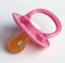

___________________________________

___________________________________

___________________________________
__________________________________________
ŠTO VIDIŠ? (2)
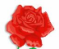
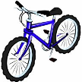
PLAVI BICIKL
______________________________
















