Što je na slici? (1)
sugl-sam-sugl-sam-sugl
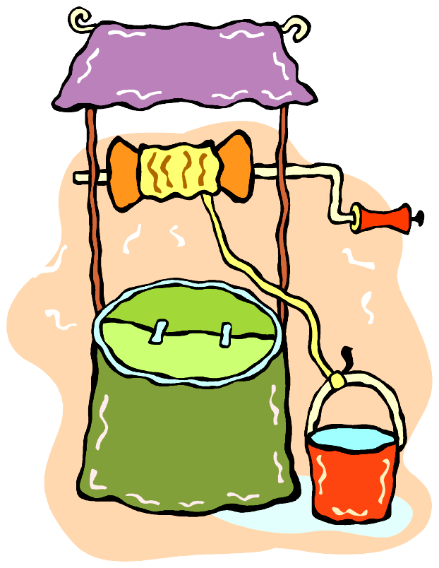
____________
____________
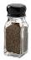
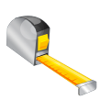
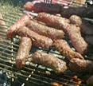
____________
____________
____________
____________
____________
____________
____________
____________
____________
____________
____________
____________
____________
____________
10
Što je na slici? (2)

____________
sugl-sam-sugl-sam-sugl
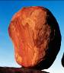
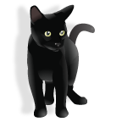
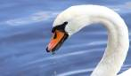
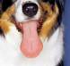
____________
____________
____________
____________
____________

____________

____________
____________
____________
____________
____________
____________
____________
____________
Što je na slici? (3)
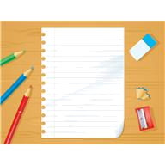
____________
sugl-sam-sugl-sam-sugl

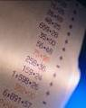


____________
____________
____________
____________
____________
____________
____________
____________
____________
____________
____________
____________
____________
____________
Što je na slici? (4)
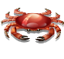
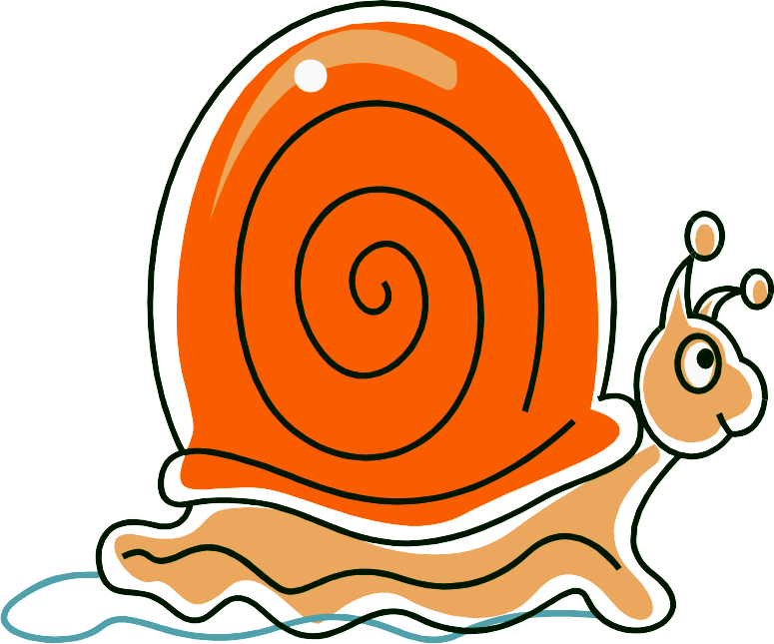
____________
____________
____________
sugl-sam-sugl-sam-sugl
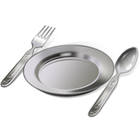
____________
____________
____________
____________
____________
____________
____________
____________
____________
____________
____________
____________
____________
____________
10
Što je na slici? (1)
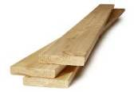
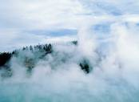
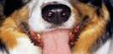
____________
____________
____________
____________
____________
____________
____________
____________
____________
____________
____________
____________
____________
____________
____________
____________-sam
sugl-sam-sugl -sugl-sam
Što je na slici? (2)
____________
____________
sugl-sam-sugl -sugl-sam
____________
____________
____________
____________
____________

____________

____________
____________
____________
____________
____________
____________
____________
____________
Što je na slici? (1)
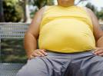
____________
sugl-sugl-sugl- ...

____________
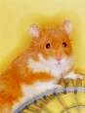
____________

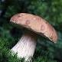
____________
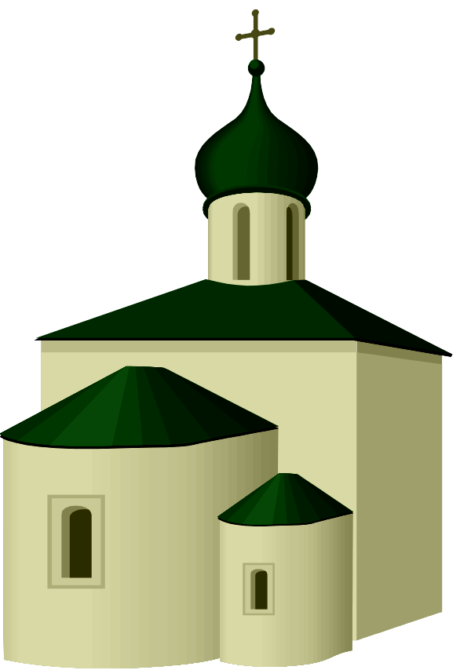
____________

____________
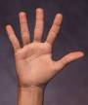
____________
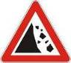
Što je na slici? (1)
____________
____________
____________
samogl- ...
____________
____________

____________







