Što je na slici? (1)
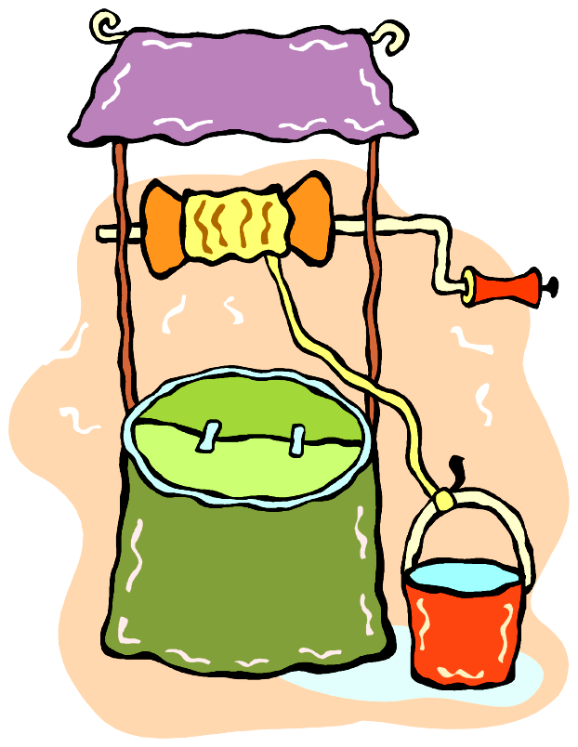
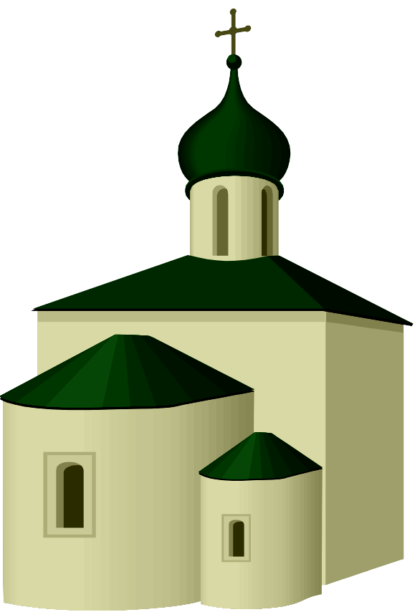
____________
____________
____________
____________
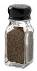
____________
____________
____________
____________
____________
____________
____________
____________
____________
____________
____________
Što je na slici? (2)
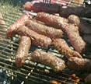
____________
10
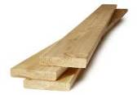
____________
____________
____________
____________
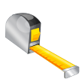
____________
____________
____________
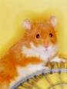
____________
____________
____________
____________
____________
____________
____________
Što je na slici? (3)
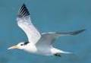

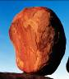
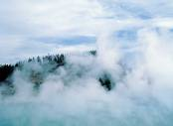
____________
____________
____________
____________
____________
____________
____________
____________
____________
____________
____________
____________
____________
____________
____________
Što je na slici? (4)
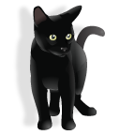
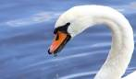
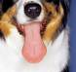
____________
____________

____________
____________
____________
____________
____________

____________
____________
____________
____________
____________
____________
____________
____________
Što je na slici? (5)
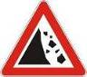
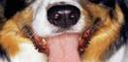
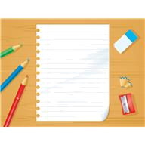
____________
____________
____________
____________
____________
____________
____________
____________
____________
____________
____________
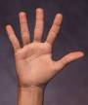
____________
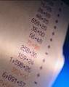
____________
____________
Što je na slici? (6)

____________
____________
____________
____________
____________
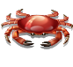
____________
____________
____________
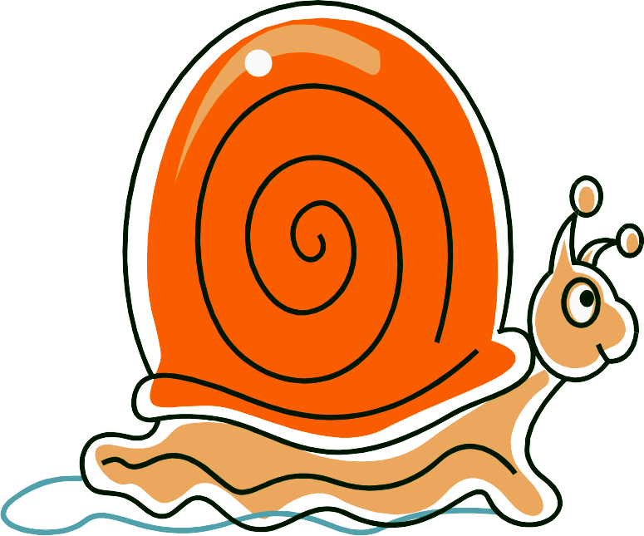
____________
____________

____________
____________
____________
____________
____________
____________
Što je na slici? (7)

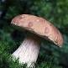
____________
____________
____________
____________
____________
____________
____________
____________
____________
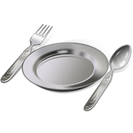
____________
____________
____________
____________
____________
Što je na slici? (8)
____________
____________








