Što je na slici? (1)
sugl-sugl-sam-sugl-sam
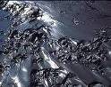
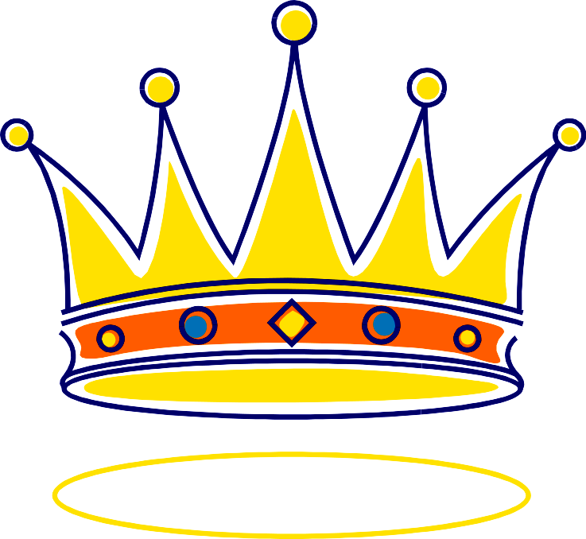
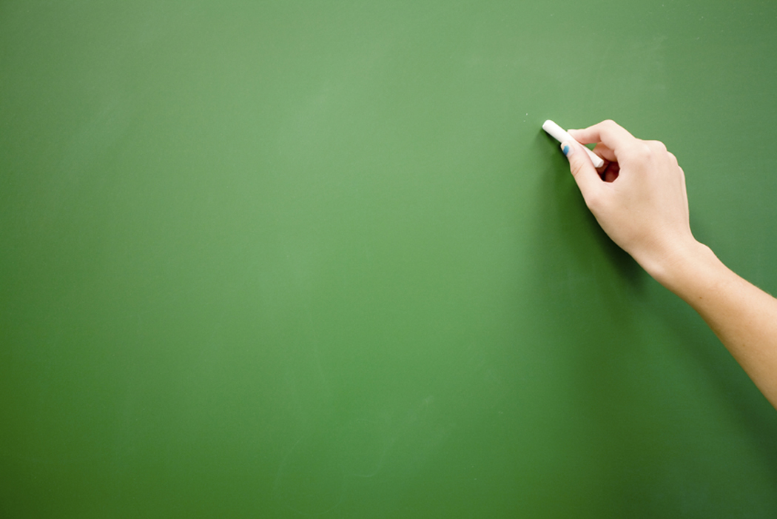
____________
____________
____________
____________
____________
____________
____________
____________
____________
____________
____________
____________
____________
____________
Što je na slici? (2)
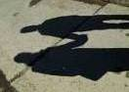
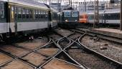
____________
____________
sugl-sugl-sam-sugl-sam
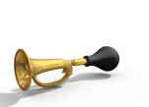
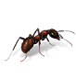
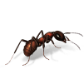
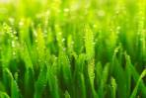
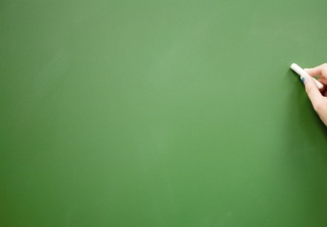

____________
____________
____________
____________
____________
____________
____________
____________
____________
____________
____________
____________
____________
Što je na slici? (3)
____________
sugl-sugl-sam-sugl-sam
____________
____________
____________
____________

____________
____________
____________
____________
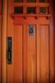
____________
____________
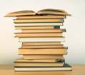
____________
____________
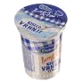
______________
____________

Što je na slici? (1)
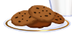
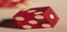
____________
____________
____________
____________
____________
____________
____________
sugl-sam-sugl-sugl-sam

____________

____________
____________

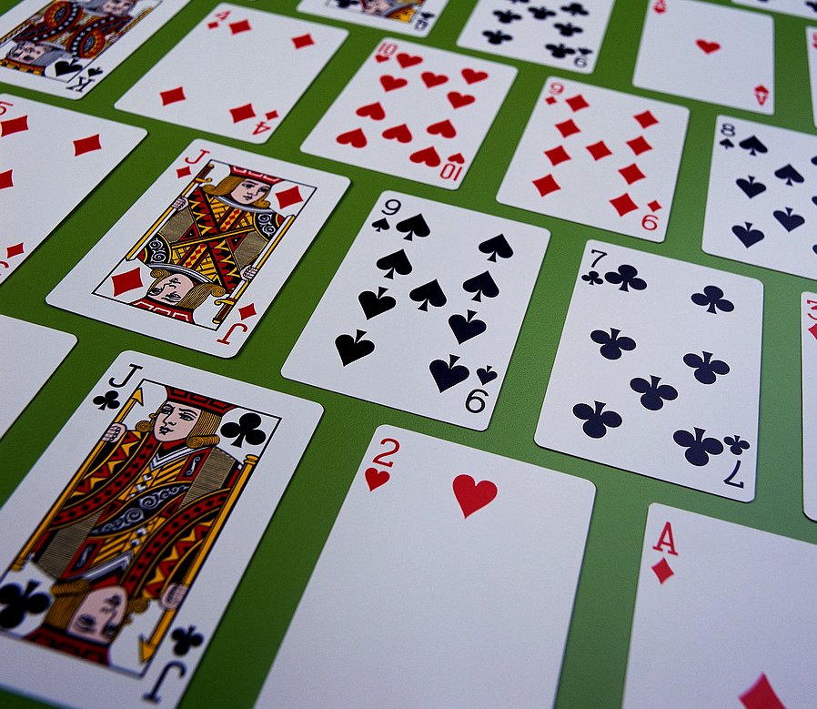
____________
____________
____________
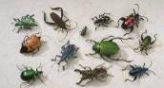
____________
____________
Što je na slici? (2)
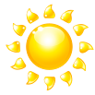
____________
sugl-sam-sugl-sugl-sam










