Što je na slici? (1)
____________
____________
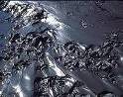
____________
____________
____________

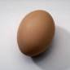
____________
____________
____________
____________
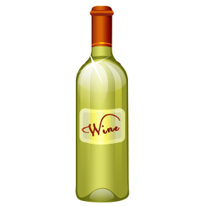
____________
____________
____________
____________
____________
____________
Što je na slici? (2)
______________ ______________

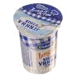
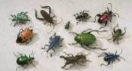
______________
____________
____________
____________
____________
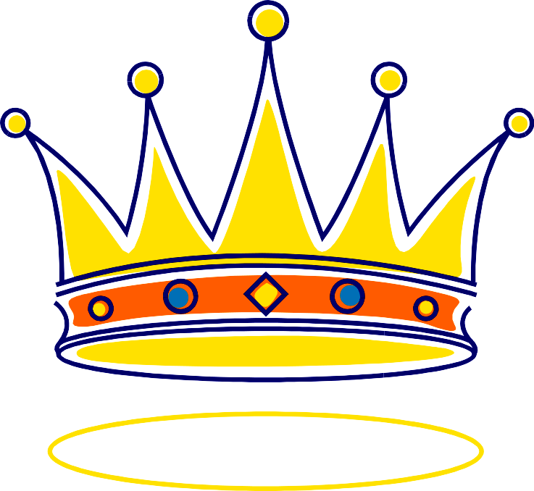
____________
____________
____________
____________
____________
____________
____________
____________
Što je na slici? (3)

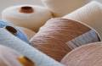
____________
____________
____________
____________
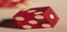
____________
____________
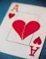
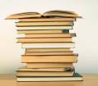
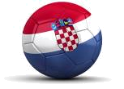
____________
____________
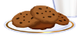
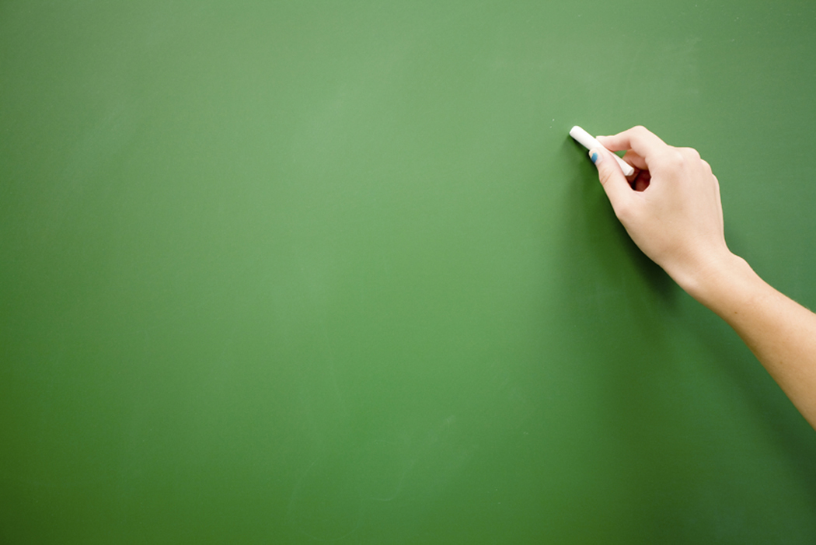
____________
____________
____________
____________
____________
____________
Što je na slici? (4)
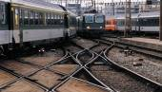
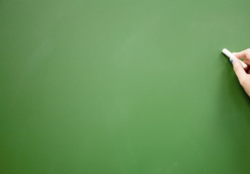
____________
____________
____________
____________
____________
____________
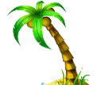
____________
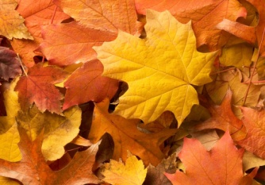
____________
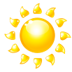
____________
____________
____________
____________
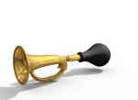
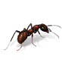
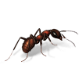
____________
____________
Što je na slici? (5)




