ŠTO JE NA SLICI? (1)
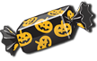
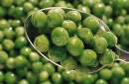
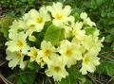
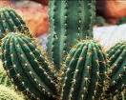

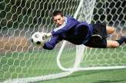
______________
______________
______________
______________
______________
______________
______________
______________
______________
______________
______________
______________
______________
______________
______________
ŠTO JE NA SLICI? (2)
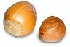
500
______________
______________
______________
______________
______________
______________
______________
______________
______________
______________
______________
______________
______________
______________
ŠTO JE NA SLICI? (3)

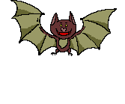

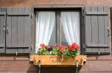
300
______________
______________
______________
______________
______________
______________
______________
______________
______________
______________
______________
______________
______________
______________

