Napiši što je spojeno:
(1)
baka i deda
______________________________

______________________________

______________________________
______________________________
______________________________
______________________________
______________________________
______________________________
______________________________
______________________________
Napiši što je spojeno:

______________________________

______________________________
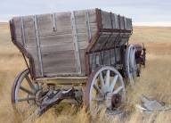

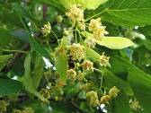
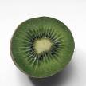
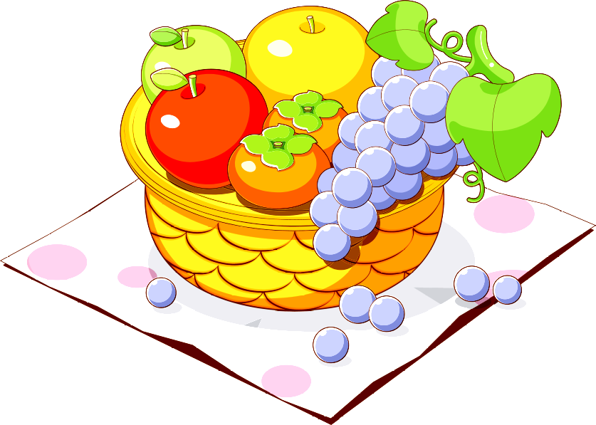
______________________________
______________________________
______________________________
______________________________
______________________________
______________________________
______________________________
______________________________
Napiši što je spojeno:

______________________________

______________________________

______________________________
______________________________
______________________________
______________________________
______________________________
______________________________
______________________________
______________________________
Napiši što je spojeno:
______________________________

______________________________


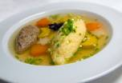
______________________________
______________________________
______________________________
______________________________
______________________________
______________________________
______________________________
______________________________
0
Napiši što je spojeno:
______________________________

______________________________


______________________________
______________________________
______________________________
______________________________
______________________________
______________________________
______________________________
______________________________
Napiši što je spojeno:

______________________________
______________________________
______________________________
______________________________
______________________________
______________________________
______________________________
______________________________
______________________________
______________________________
Napiši što je spojeno:

______________________________

______________________________
______________________________
______________________________
______________________________
______________________________
______________________________
______________________________
______________________________
______________________________
Napiši što je spojeno:
*

______________________________
______________________________
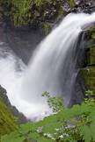
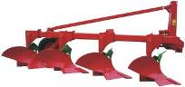
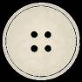
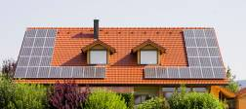
______________________________
______________________________
______________________________
______________________________
______________________________
______________________________
______________________________
______________________________
Napiši što je spojeno:
*

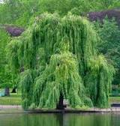
______________________________

______________________________
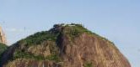
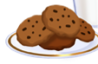

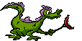
______________________________
______________________________
______________________________
______________________________
______________________________
______________________________
______________________________
______________________________
Napiši što je spojeno:
*

______________________________

______________________________
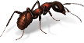
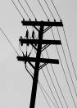
______________________________
______________________________
______________________________
______________________________
______________________________
______________________________
______________________________
__________________________________________
Napiši što je spojeno:
______________________________
______________________________
______________________________
______________________________
______________________________
______________________________
______________________________
______________________________
______________________________
*

__________________________________________
Napiši što je spojeno:

______________________________
______________________________
______________________________
______________________________
______________________________
______________________________
______________________________
______________________________
______________________________
______________________________
*


(1)

